nepal college of information technology MODEL QUESTION

Level: Bachelor
Programme: BE |  | Full Marks: 100
Course: Calculus I |  | Time : 3hrs.

Candidates are required to give their answers in their own words as far as practicable.
The figures in the margin indicate full marks.

Attempt all the questions.

 | 1a. A function is defined as follows  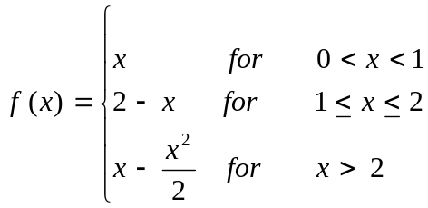  Is 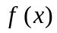 continuous at x = 2? Does 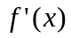 exist at this point?  b. If y = (sin⁻¹ x)², prove that (1 – x²) y₂ – xy₁ – 2 = 0 and hence show that (1 – x²) y_{n+2} – (2n +1) xy_{n+1} – n² y_{n} = 0 . 5  - State Lagranges mean value and give its geometrical meaning. Using it, show that, if f (x) > 0 in [a, b] function f(x) is increasing in [a, b]. |  | 5  5
 | - a. Evaluate 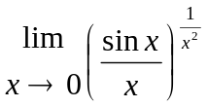  b. Find the asymptotes for the curve x²(x-y)²-a²(x²+y²)=0 5  c. Define radius of curvature of the curve. Find radius of curvature of the curve 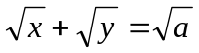at a point where it meets the line y=x.  OR  Trace the curve y²(2a-x)=x³ 5 |  | 5
3 | Integrate for the following  - 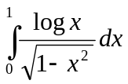  b). Obtain the reduction formula for 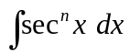 and hence evaluate : 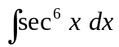.  c). Show that 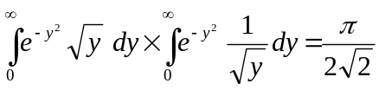. |  | 3×5
4 | - Solve 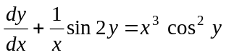  - Solve: 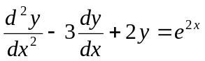 5 |  | 5
- Solve y" +9y = sec3x by Wronskian method 5
- a) Solve the following initial value problem.
y" + y' – 2y = 0, y(0) = 4, y' (0) = 1. 5

6 | - Write down the criteria for a function ƒ(x, y) of two variables x & y to have maximum or minimum values at a point. Find the minimum value of 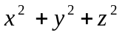such that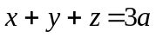.  - State and prove Eulers theorem for homogeneous function of two variables in x and y of degree n. If u = log 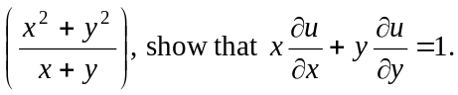 |  | 7  8
7 | Solve the following:  - Find domain and range of the function y = 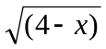.  - Evaluate 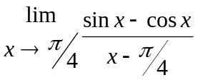.  - Find the arc length of the curve, 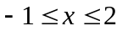.  - Evaluate 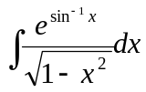 | 5×2.5=10

